**AVD**

Azure Virtual Desktop (AVD) is a desktop and application virtualization service hosted on the Microsoft Azure cloud platform. It allows you to run desktops and applications in the cloud, **providing a remote desktop experience from anywhere**.

Provides a multi-session Windows 10 or 11 experience, which is optimized for Office 365 ProPlus.

Leverages Azure’s security features, including conditional access, multi-factor authentication, and security monitoring.

How To Create Azure Virtual Desktop: -

Step 1-

Note- you will not get option to create new VNET and Subnet while crating Host Pool. So, create required VNET and Subnet if you want to create new for AVD.

Go to Azure and search for Azure Virtual Desktop

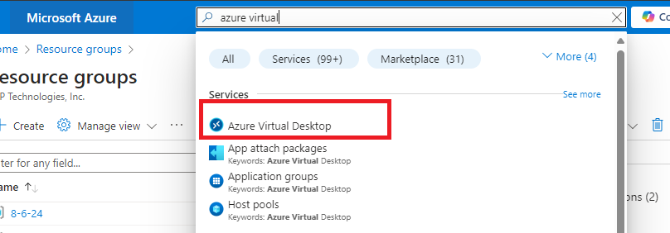

Step 2-

Create Hostpool

A host pool is a collection of Azure virtual machines (VMs).

Feel the required details such as Host pool the location and resource group you want to create resources.

**Preferred app group type:-**

"Preferred app group type" setting is used to define the default method by which users will access resources within a host pool.

There are two main types of app groups in AVD:

1. Desktop - "Desktop Application Group (DAG)" Provides access to a full desktop experience.  
   Users can use the desktop just as if they were sitting in front of a physical Windows machine.  
   Suitable for scenarios where users need a complete Windows desktop environment.
2. Remote App - "RemoteApp Application Group (RAG)" Provides access to individual applications rather than a full desktop.

Users launch and interact with remote applications as if they were installed on their local device.

Suitable for scenarios where users only need specific applications rather than a full desktop environment.

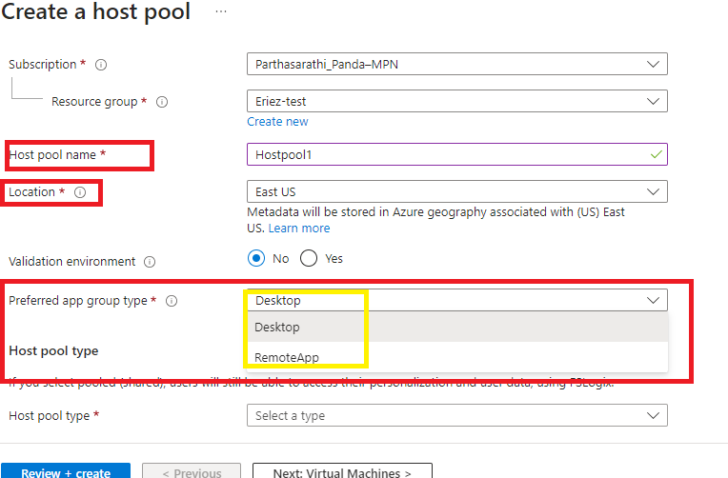

Choosing Desktop operation-

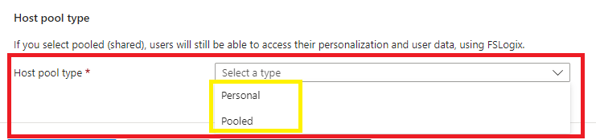

Choose Host pool Type-

1. Personal - Dedicated Virtual Machines: Each user is assigned their own dedicated virtual machine (VM).

Persistent Environment: Users have a persistent desktop environment where their settings, applications, and data are retained between sessions.

Use Case: Suitable for users who need a consistent and personalized desktop experience, such as developers or power users.

ex- You have 5 employees, and each of them needs their own personal desktop with their own software, settings, and files.

These employees often work on projects that require a stable and consistent environment.

Dedicated VM: Each of the 5 employees gets their own dedicated virtual machine.

Consistency: All their files, settings, and applications are saved and available each time they log in.

Example: Imagine you have five physical laptops, one for each employee. Each laptop is customized for its user and keeps their data and settings.

Useful where users need their own consistent workspace and stability.

1. Pooled - This is like "Shared Virtual Machines" Multiple users share a pool of VMs.

Non-Persistent Environment: User settings and data are typically not preserved between sessions, although FSLogix can be used to store user profiles and ensure personalization and user data persist.

Use Case: Suitable for task workers or scenarios where users do not need a personalized environment, allowing for more efficient use of resources by dynamically allocating VMs based on demand.

Example: Imagine you have a library with 5 computers. Any employee can use any computer when they need to, and once they are done, the next person can use the same computer.

Best use to save cost, shared the resources among employees. suppose if monitoring team is having 15 members 5 are in MS and 5 are in ES and 5 are in NS. so, 5 servers can fulfil the requirements. because users are using separate time. once ms peoples are logged out ES peopled can login. it is like any user can use any server if it's available.

Choose Assignment Type –

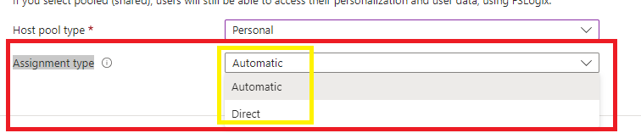

1. Automatic – Users will be assigned to any available VM once they login, best for shared pool where any users use any system for cost saving.
2. Direct – users will always will be directed to a specific vm once they login, best for personal.

Add Virtual Machines to Host Pool-

Provide the required details for Virtual Machines. And session host.  
  
Session Host – The individual VMs within a host pool. These are the actual servers (or virtual machines) that users connect to when accessing their virtual desktops or applications.

The users will be assigned to session hosts to use.

If the user need other servers permission we need to assign role on individual virtual machines. So the user by logging to session can take RDP to required server.

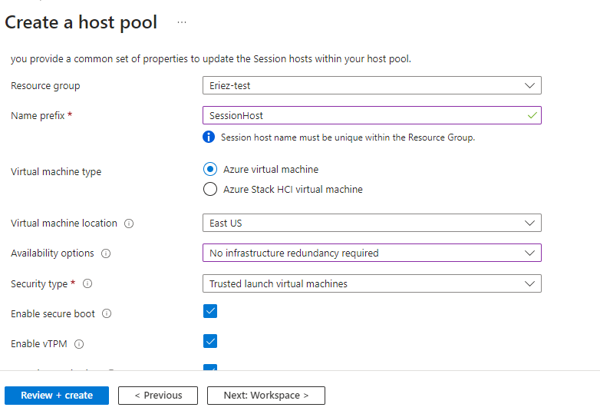

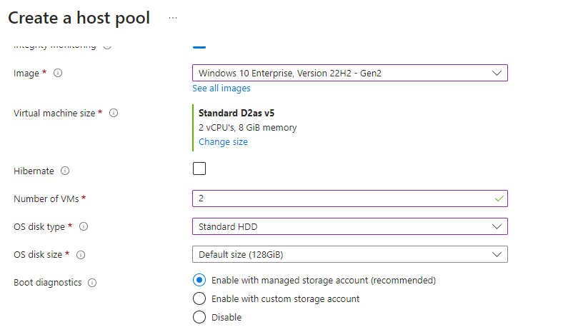

If we want boot diagnostics, we need to have storage account. Else can disable.

Domain to Join

What kind of authentication we want to enable for the users by MS Entra ID or AD

This user name and password will be administered, we can access to any server in host pool.

Create Workspace –

We can create workspace later and attach to target hostpool.

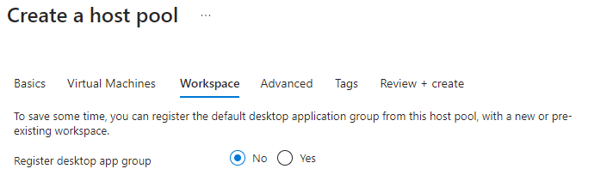

Provide required tags and create.

Step 3-

Application Group-

Application groups are essential for organizing and controlling access to the applications and desktops that users can use within AVD.

**Purpose:** Provides users with access to a full virtual desktop environment.

**Use Case:** Suitable for users who need a complete Windows desktop experience, where they can use multiple applications as if they were on a local PC.

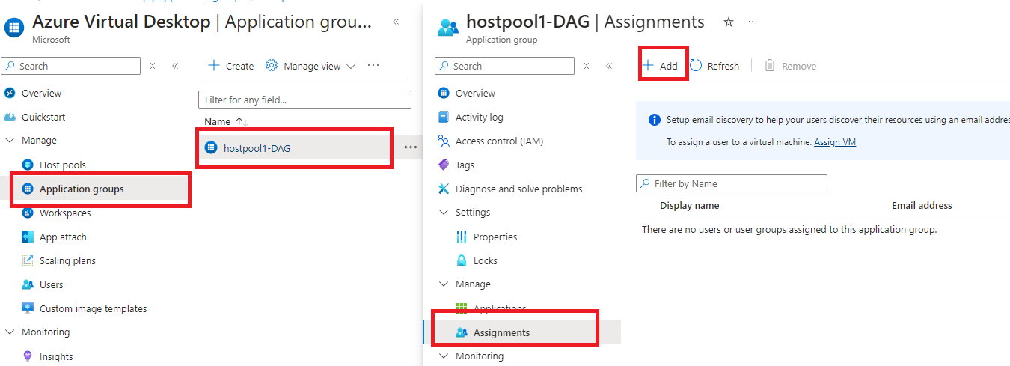

To allow users to desktop we need to add the users to application groups -> assignments

Then the user will see the server on their account to access.  
  
Note- The account we want to provide access to AVD that account must be on same domain.

Ex- If we created AVD in SNP domain (@snp.com) the user must be in snp such as- [user1@snp.com](mailto:user1@snp.com).

We can not assign access to other domain user such as [user2@xyz.com](mailto:user2@xyz.com).

The user will not get access.

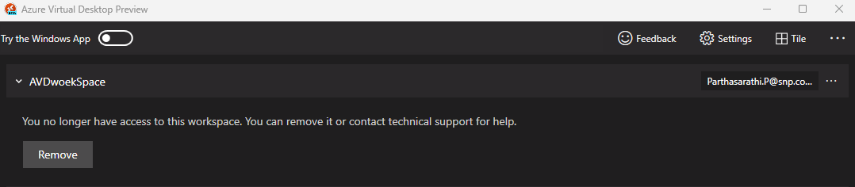

The above screenshot state that the user [Parthasarathi.p@snp.com](mailto:Parthasarathi.p@snp.com) has no active AVD server assigned. The the server was previously assigned is been deleted (no longer exists).

Assign user-

On application group click on assignments under manage click on add button select the user and assign.

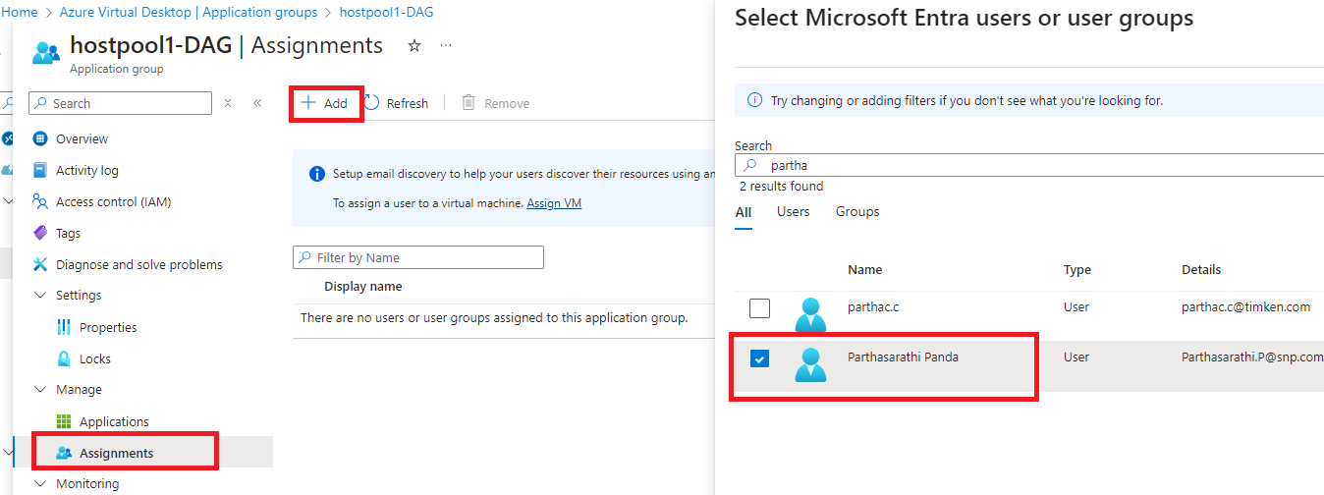

The user will be added. But, if we notice the user still will not be able to access the session host.

The reason is there is no assigned VM for the user. We have just added the user to host pool now we need to assign VM for the user.

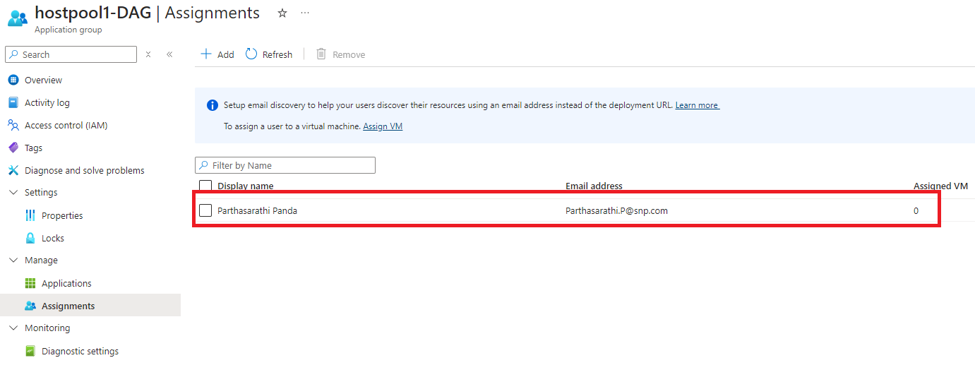

Assign the session host to the added user

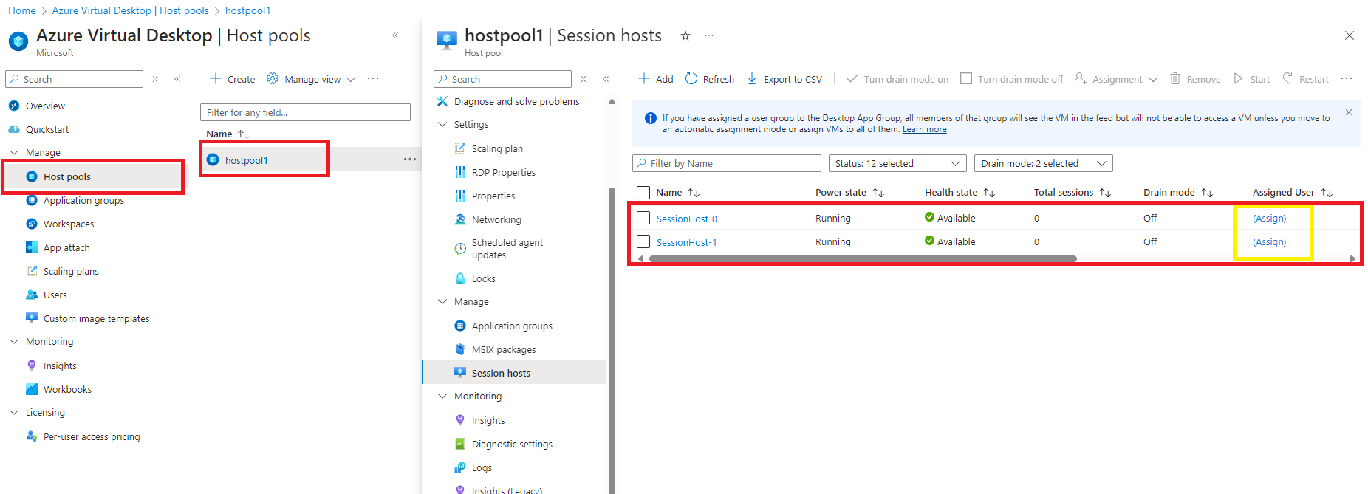

Go to Host Pool find session hosts under manage section. Select the server want to assign for the user, click on assign select the user and assign .

Note- if you don’t find the assign option here on server row, then select the server, click on assignment option on top and assign.

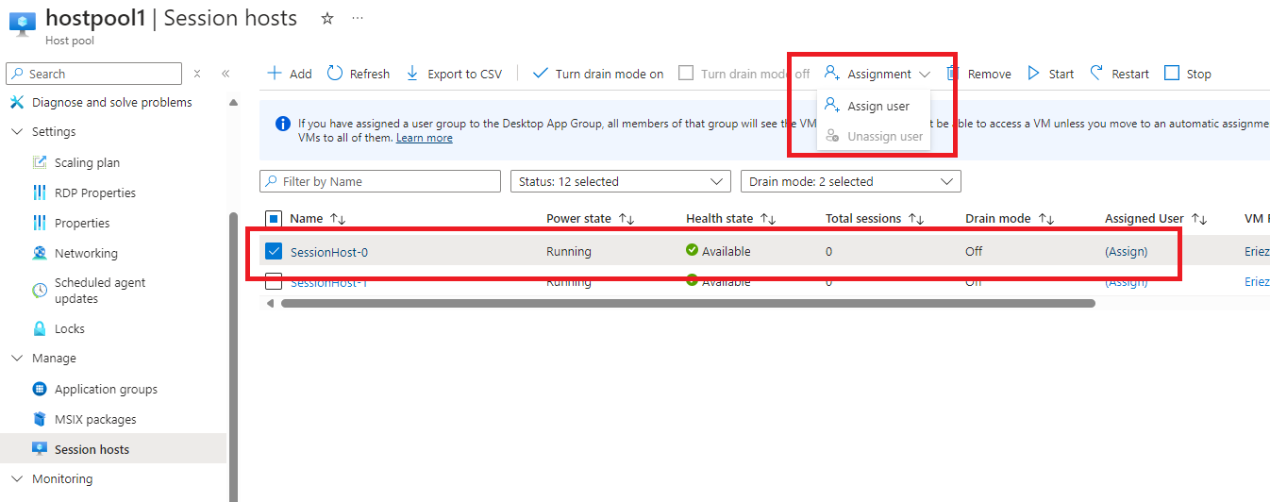

Can select user and assign,

Note- we will see only those users are added to application group to assign server.

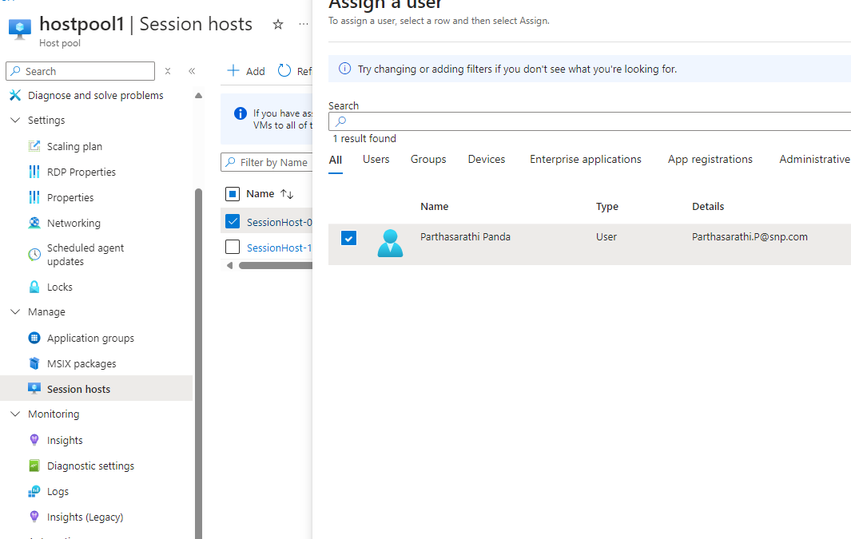

User will be assigned successfully.



Now, Go to azure virtual desktop application on our local workstation and refresh to get the assigned session host.

Still, we won’t be able to find the assigned session host. We can cross verify that the session host is assigned successfully to the user from application group.

Go to Application group click on assignments will see the added user and assigned vm.

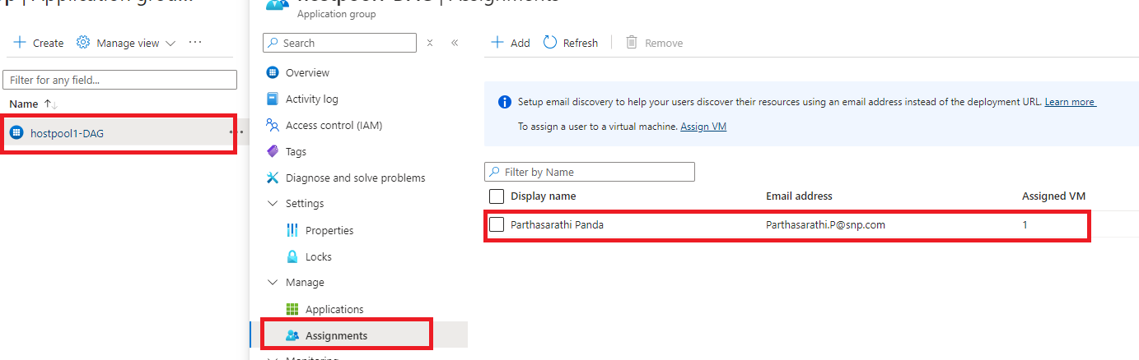

This is due to missing workspace.

Workspace –

A **workspace** is a logical container that groups together application groups (both desktop and RemoteApp application groups) and provides a unified access point for users. It serves as the user-facing entry point for accessing virtual desktops and remote applications.

The workspace is the endpoint where users connect to access their assigned desktops and applications.

Create Workspace-

Fill the required details and create.

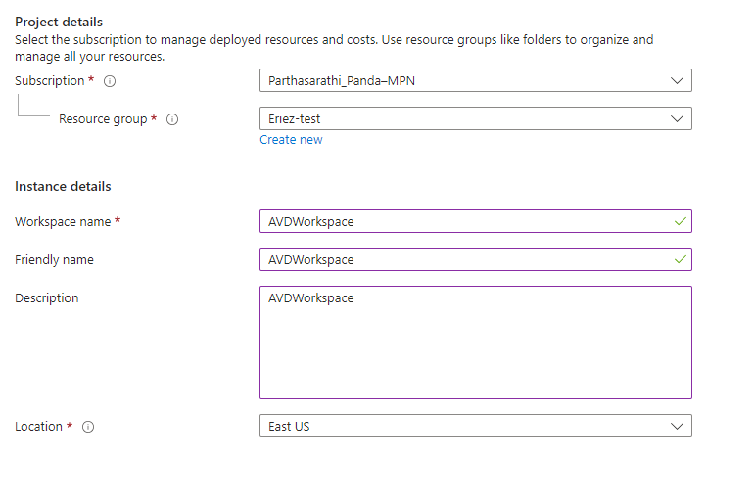

Workspace will be created.

Now we need to ling the workspace with application group.

Go to Workspace choose application groups under manage section from left hand menu bar.

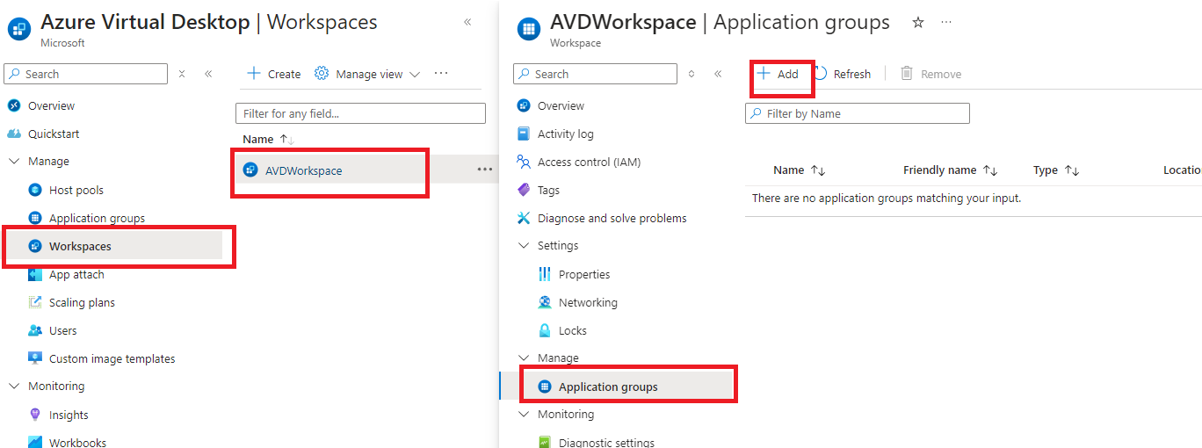

Click on add option.

Choose the targeted application group where we added users to get access to session host and add.

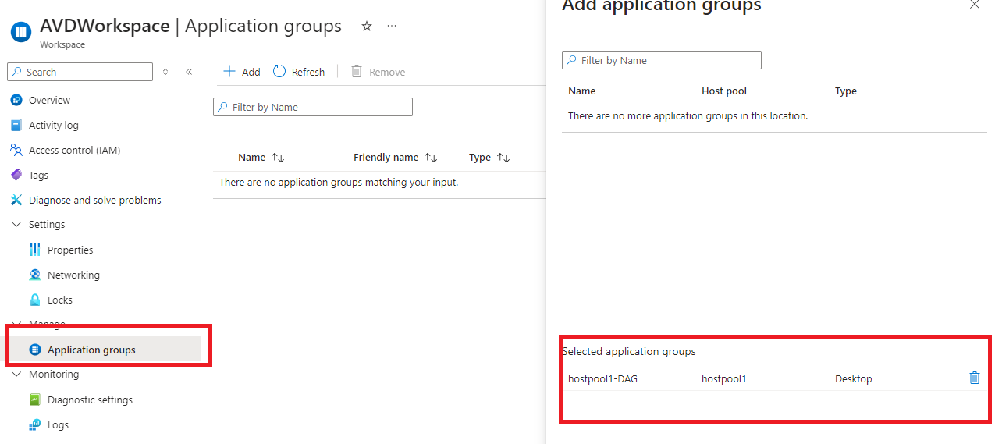

Verify the application group added successfully.

Now the user will get access to assigned session host.

Now if we try to login to session host it will fail. This is due to we don’t have any specific role to that virtual machine. Assign role to that server. But we can login as admin ( the admin credentials we provided at the time of creation hostpool), by using this admin we can also take RDP to any servers.

But, we will be able to see session hosts login page.

Choose the user account you want to login.

Here the user’s password will be his primary domain account password. Ex – the password for azure account [Parthasarathi.p@snp.com](mailto:Parthasarathi.p@snp.com).

We will be failed to connect but can verify connection by admin username and password.

If you see the below error during connecting to session host make sure that session host is in running state without any issue.

Go to host pool and select the assigned server.

Click on server name to go to the server.

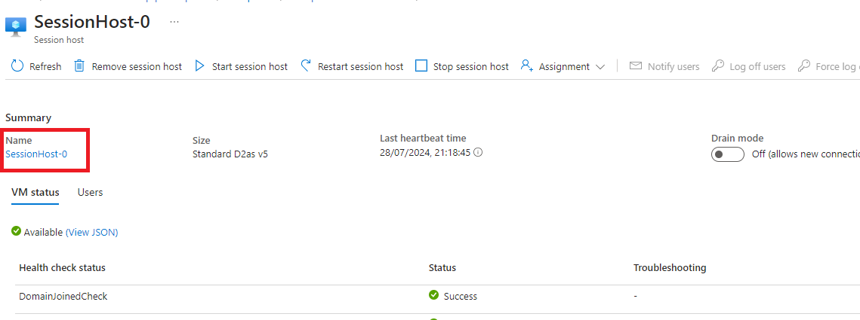

On virtual machine go for assigning role

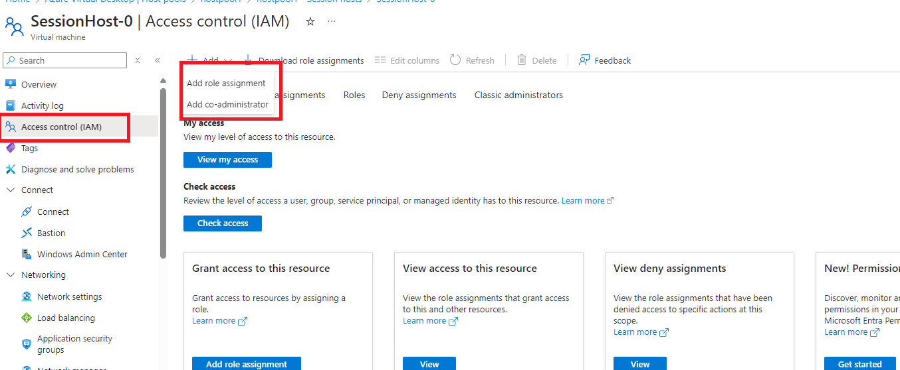

Select user and assign Virtual Machine Contributor login role this will allow users to login to server. This provide one more level of security, by RBAC.

You can assign any role you want.

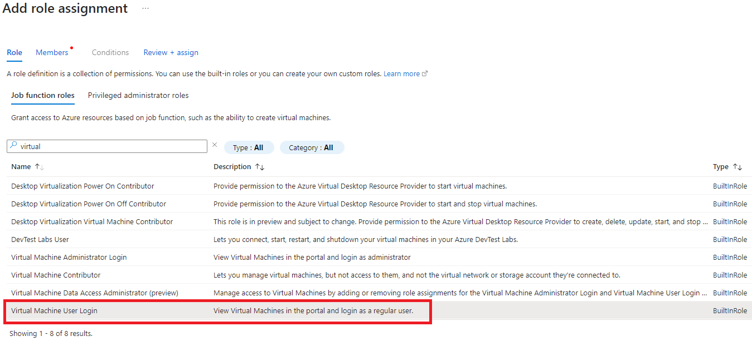

Verify your access assigned successfully.

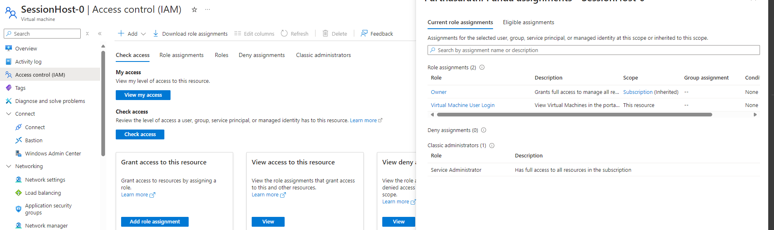

Now try to login by user account, it will connect successfully.

Now if we try to take RDP to 2nd server from session host will face same issue, to resolve assign role for the user on required servers.

Same way can add number of users and assign session host for them and assign role.

**Try another Configurations such as remote app type host pool, pooled host pool type.**

Create another Host pool.

Creating another host pool, this time choosing preferred app group type is remote, so the users will have access to the assigned application rather then the entire desktop which we did previously.

Keeping host pool type personal.

This time creating session host name as remote.

Provide other required details such as admin user details, VNET, workspace details (I am creating new workspace name as “workspace2”) and create.

Another application group will be created and it will be linked with work space (workspace2)

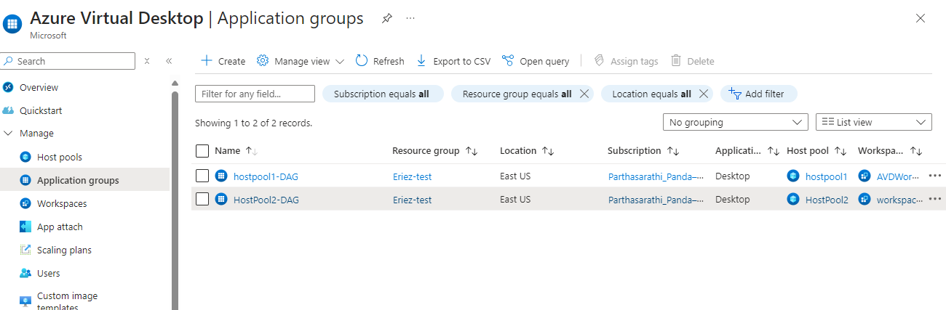

Assign user to it. And assign vm to user.

After successful assignment user will see that new workspace and assigned vm to him.

